STAGE ONE:  INFORMAL  Complainant to proceed to Stage 2 by informing the school within 10 school working days | Expression of concern to member of staff / Response within 5 school days  Satisfactory outcome reached?  No: Go to stage 2 Yes: No further action
STAGE TWO:  HEADTEACHER’S  INVESTIGATION  Complainant to proceed to  Stage 3 by informing the school  within 10 school working days | Complainant makes verbal/written complaint to headteacher  Investigation conducted and outcome reported to complainant. Response within 3 school days  Satisfactory outcome reached?  No: Go to stage 3 Yes: No further action
School Complaints Flow Chart  STAGE THREE:  CHAIR OF GOVERNORS/  GOVERNORS  INVESTIGATION  Complainant to proceed to  Stage 3 by informing the school  within 10 school working days | If the complainant is not satisfied with the response of the headteacher or the complaint is about the headteacher, the complainant should write to the Chair of Governors to request that their complaint is considered further.  Investigation conducted and outcome reported to complainant.  Satisfactory outcome reached?  No: Go to stage 4 Yes: No further action
STAGE FOUR:  GOVERNORS’  APPEAL PANEL | If the complainant is not satisfied with the response of the Chair. The complainant usually needs to write to the Clerk to the Governing Body giving details of the complaint and asking that it is put before the appeal panel ( Response within 5school days). The Chair, or if the Chair has been involved at any previous stage in the process, a nominated governor, will convene a GB complaints panel.  The governors’ appeal hearing is the last school-based stage of the complaints process and is not convened merely to rubber-stamp previous decisions. .
FINAL STAGE: FURTHER RIGHT OF PROGRESSING COMPLAINT

The Chair of the above Panel needs to ensure that the complainant is notified of the panel’s decision, in writing, with the panel’s response (including the reasons for the decision); this is usually within a set deadline which is publicised in the procedure. The letter needs to explain if there are any further rights of appeal and, if so, to whom they need to be addressed. This may be the LA or Diocesan Board.

The final stage of appeal is to the Secretary of State for Education.
Complainants should be advised to write to The School Complaints Unit (SCU) at:

Department for Education, 2nd Floor, Piccadilly Gate, Manchester, M1 2WD

Stage One Flowchart
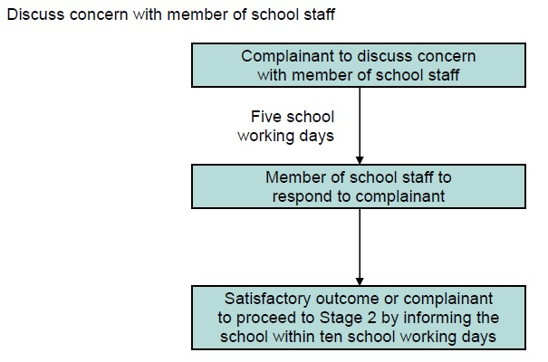
Stage Two Flowchart

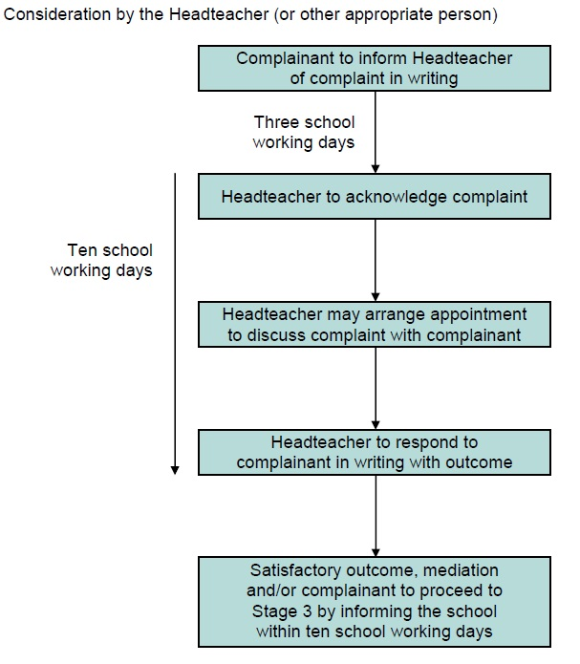

Stage Three flowchart

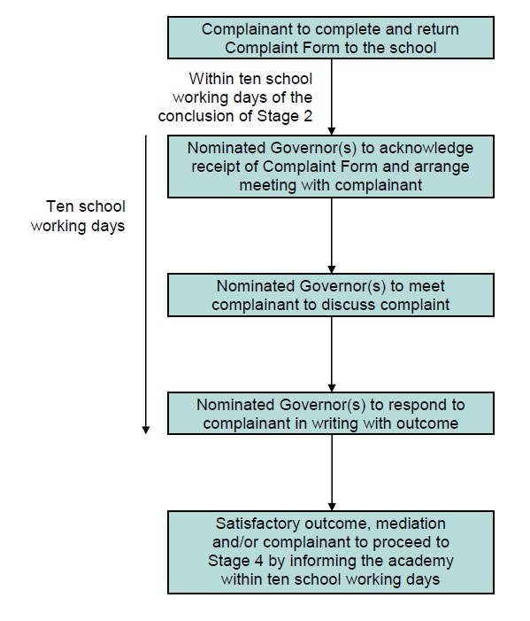

Stage Four Flowchart

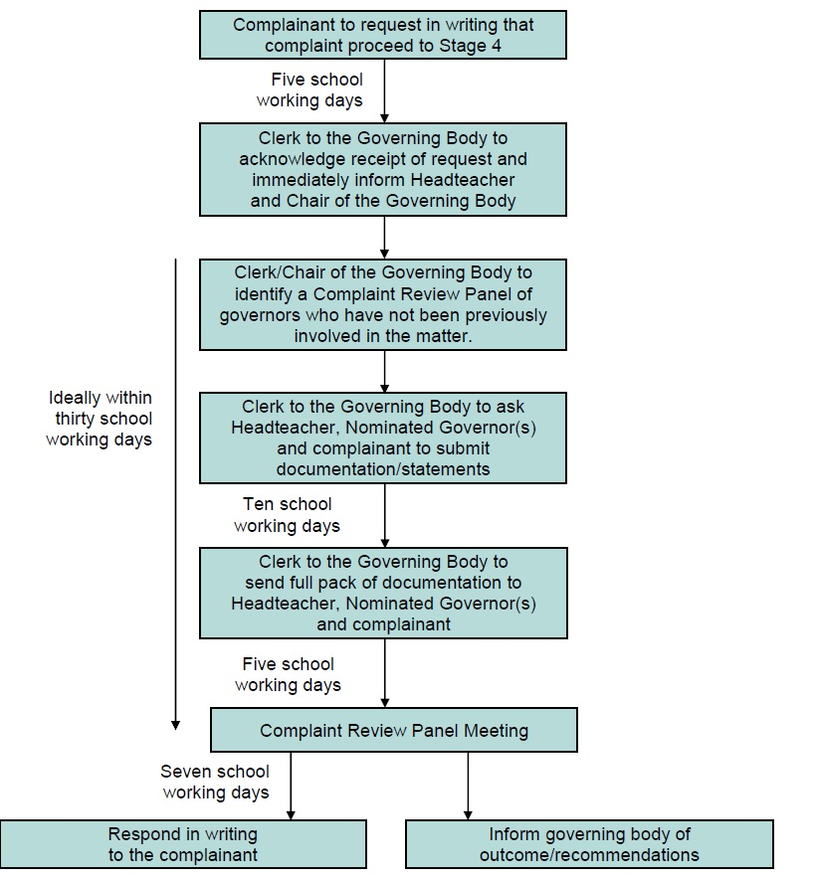

Time Limits: Complaints need to be considered, and resolved, as quickly and efficiently as possible. This procedure requires that specific time limits for all action within every stage are observed. Where further investigations are necessary, new time limits should be set and the complainant would need to be informed of this change and the reason
Time Limits: Complaints need to be considered, and resolved, as quickly and efficiently as possible. This procedure requires that specific time limits for all action within every stage are observed. Where further investigations are necessary, new time limits should be set and the complainant would need to be informed of this change and the reason
The stages of the complaint

Stage One (informal): complaint heard by staff member
It is in everyone’s interest that complaints are resolved at the earliest possible stage. The experience of the first contact between the complainant and the school can be crucial in determining whether the complaint will escalate. To that end, if staff are made aware of the procedures, they will know what to do when they receive a complaint.

It would assist the procedure if the school respected the views of a complainant who indicates that he/she would have difficulty discussing a complaint with a particular member of staff. In these cases, the complaints co-ordinator can refer the complainant to another staff member. Where the complaint concerns the headteacher, the complaints co-ordinator can refer the complainant to the Chair of Governors.

Similarly, if the member of staff directly involved feels too compromised to deal with a complaint, the complaints co-ordinator may consider referring the complainant to another staff member. The member of staff may be more senior but does not have to be. The ability to consider the complaint objectively and impartially is crucial.

Where the first approach is made to a governor, the next step would be to refer the complainant to the appropriate person and advise them about the procedure. It would be useful if governors did not act unilaterally on an individual complaint outside the formal procedure or be involved at the early stages in case they are needed to sit on a panel at a later stage of the procedure.

Stage Two (formal): complaint heard by headteacher
The headteacher’s influence will already have shaped the way complaints are handled in the school. At this point, the complainant may be dissatisfied with the way the complaint was handled at Stage 1 as well as pursuing their initial complaint. The head may delegate the task of collating the information to another staff member but not the decision on the action to be taken.

Stage Three (formal): complaint heard by Chair of Governors
If the complainant is not satisfied with the response of the headteacher or the complaint is about the headteacher, the complainant should write to the Chair of Governors to request that their complaint is considered further..
Stage Four (formal): complaint heard by Governing Bodies Complaints Appeal Panel
The complainant usually needs to write to the Clerk to the Governing Body giving details of the complaint and asking that it is put before the appeal panel. The Chair, or if the Chair has been involved at any previous stage in the process, a nominated governor, will convene a GB complaints panel.

The governors’ appeal hearing is the last school-based stage of the complaints process and is not convened merely to rubber-stamp previous decisions.
Individual complaints would not be heard by the whole GB at any stage, as this could compromise the impartiality of any panel set up for a disciplinary hearing against a member of staff following a serious complaint.

The governing body may nominate a number of members with delegated powers to hear complaints at that stage, and set out its terms of reference. These can include:

• drawing up its procedures;
• hearing individual appeals;
• making recommendations on policy as a result of complaints.

The procedure adopted by the panel for hearing appeals would normally be part of the school’s complaints procedure.

.

