Miss Cope’s Bean Seeds – Day 7
Use your own seeds or look at photos of mine
Look at the bean seed in the jam jar, has anything happened? Introduce/ use the word germinate.
What is growing out of the seed? Discuss it is the root or shoot?
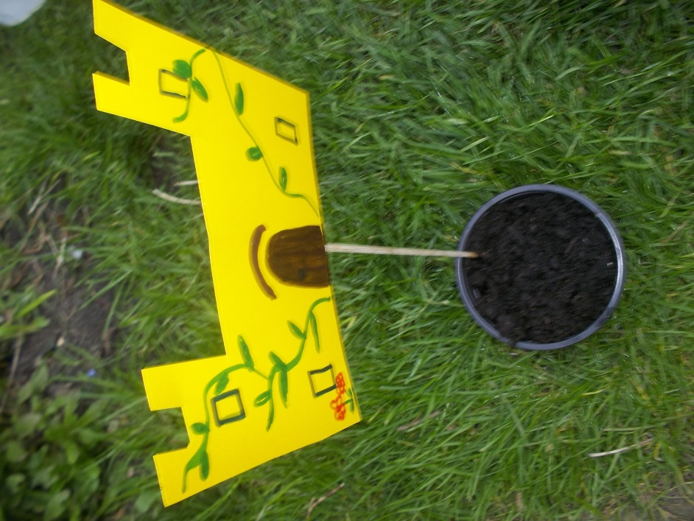
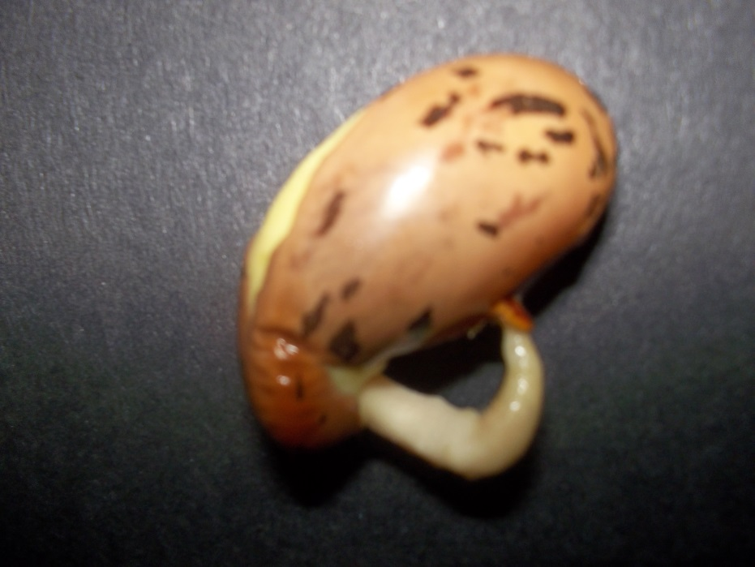
Write a sentence
Close up of the jam jar bean seed

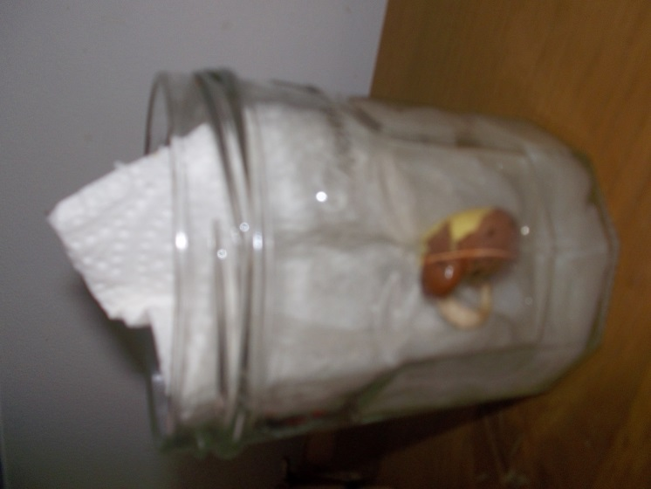

Is the seed in the soil growing? What could be happening?
Remember to water your seeds and keep inside overnight.

