Planting the bean seed ( WALT follow instructions)
You will need a flower pot or something similar, compost or soil, a trowel or large spoon, a seed, water.
Please read these instructions to your child.
- Half fill the pot with soil.
- Put the seed on the soil.
- Cover the seed with more soil. (Fill the pot)
- Water the soil in the pot. (Dampen it)

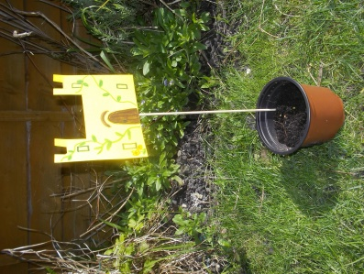
I have planted my bean seed and made my castle. I will keep my flower pot on a sunny windowsill indoors.

