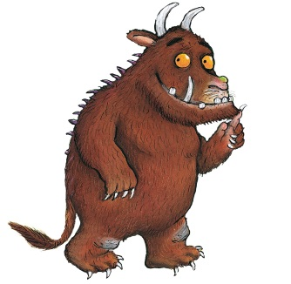

Can you turn the Gruffalo…
A half turn | A quarter turn | A whole turn
A quarter turn clockwise | A half turn  anti-clockwise | Three quarter turn clockwise
A whole turn  anti-clockwise | Three quarter turn anti-clockwise
