Key Stage 1
Daily Learning Year 1 | Date: 1.4.2020
The guidance in this bulletin is intended to support the continuing education for your child in the event of school closure. Activities and resources have been carefully sourced to be easy to deliver. The weekly timetable would usually include approx. 6 hours of creative learning and physical exercise. These areas can be fulfilled at home with activities of your choice. We would expect approx. 3 hours per day to be spent on directed activities. Please use the office email office@tssfirst.co.uk if you have any queries with your home learning or your teachers work email (h.horth@tssfirst.co.uk)

General:

I am trying to attach resources to help you. Please do not feel the need to print them all out; they can be used as a guidance only.

PE:
Joe Wicks is doing daily PE lessons on his YouTube channel at 9am. This could be a fun way of keeping fit and doing a bit of exercise.

https://www.premier-education.com/stay-active/ The following link is from Premier Sports. It is free to sign up and they will give you some great ideas about staying active at home.

Blog:
I will be putting up a Year 1 blog every Friday. Please do send me pictures of your child’s learning or describing something they have done so I can add it to the blog. By sending me pictures you are agreeing that they can go on the school website. I may not be able to put all the pictures up but I will choose a selection each week.

Zoom:
I am really enjoying our Zoom meetings. This is a great chance you ‘catch up’ and to share what we have been doing. Please feel free to bring a piece of learning to show the rest of the class.
I would like to arrange another Zoom meeting for Friday 3rd April at 4pm. This will be our last meeting before the Easter holidays.

Phonics/Spelling:  Please focus on the phase 3 sounds ng and th and the phase 5 sounds ey and a-e.  Get your child to read these sounds and then write them down.  Words to practise writing today:  hang, song, bang  that, bath, think  donkey, honey, money  amaze, shape, make  Can you make your own spelling word flashcards today.  Some games to play:  Turn them over and then turn each word over checking that you can read it and then write it down.  Get an adult to hide your words around the house and you hunt for each one writing it down as you find it.  https://www.youtube.com/watch?v=YPW-ZkhRUPY Please click on the link to practise the phase 5 sound song.  Please visit www.phonicsplay.co.uk and you can access all resources using the login:  Username- march20  Password- home  Please play the tricky word brain game to help you learn your tricky words.  Tricky words spellings:  Please learn the words below and put each word into a sentence:  Mr, Mrs, called, looked, their, people | Mental Maths/Times Tables:  Please log on to purple mash and play the number bond bubble game  https://www.purplemash.com/#app/games/bondbubbles  IF the link does not work you can search for it/ or it under games.  Activity:  Today I would like you to pick a number- this is an opportunity to challenge yourself.  Write your number in the middle of your page.  Think of as many different ways you can to make that number- this could involve adding and subtracting.  Eg if you choose 20  10 + 10 = 20  25 – 5 =20  Make sure you write each number sentence out correctly.  You could time yourself and give yourself a challenge of how many you can think of in 1 minute/3 minutes etc.
Reading:  Today I would like you to pick a non-fiction to read.  Please complete the Non-fiction book review that I have attached.  You can either print it out or write the answers in your exercise book. | Mathematics:  Starter activity:  Use a 100 square for this activity.  Give your child a number and they have to tell you one more and one less.  Then you can challenge them and ask them 2 more/2 less etc.  Main activity: We are now going to be looking at money  Objective: I know the value of coins and notes  First challenge:  To have a selection of coins (if you don’t have coins at the moment as everyone is using card I am attaching some coins you can print- or you can draw your own!)  Get your child to sort the coins- can they recognise each coin?  Can they put the coins in order from the lowest value to the highest value. Support them with this if they struggle.  Second challenge:  I would like the children to new stick/ draw the coins in their book from lowest value to highest value.  Next to each coin I would like them to write what it is eg 5p , £1  (I am attaching coins they can cut out if they would like to but they can draw their own)  Game:  You could put your coins in a heap in the middle and then call out a coin and see how quickly your child can collect all the coins that you called out.
Writing:

Starter activity:
Can you think of 8 words that begin with T.
Write them down.

Choose 3 of your words to put into a sentence. Remember your capital letters and full stops!

Main activity:
Today we are going to think about how we celebrate Easter and how people around the world celebrate it.

https://www.youtube.com/watch?v=StlJgYF-Ki8 This clip is about celebrating Easter.

I would like your child to write 2 sentences about how they celebrate Easter/ something they might do in the Easter holidays if you do not celebrate Easter.

I am then attaching a PowerPoint to look at. This will be about how Easter is celebrated around the World.

Can you pick one country and write about how they celebrate Easter. Please focus on capital letters and full stops when writing sentences and also encouraging your child to sound out and not to copy.

Foundation subjects. Today’s focus: DT

Focus- Fruit Salads

Before school closed we did some fruit tasting and were aiming to make our own fruit salads in the shape of a space rocket.

I would like you to use different fruits to create your space rocket at home. Use fruits you like and try to do all the cutting yourself (with an adult supervising of course!)

You can send me a picture of your fruit salads and I can put them on the class blog.

(This can be done when you have been shopping and got fruit in!)
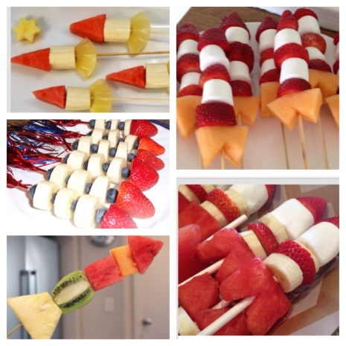
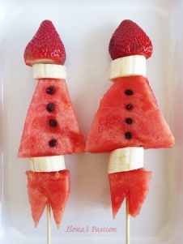
Here are some examples from the internet but please do be as imaginative as you want:
