Maths

1. Basic telling the time. Write each time in your book and ask an adult to check them.

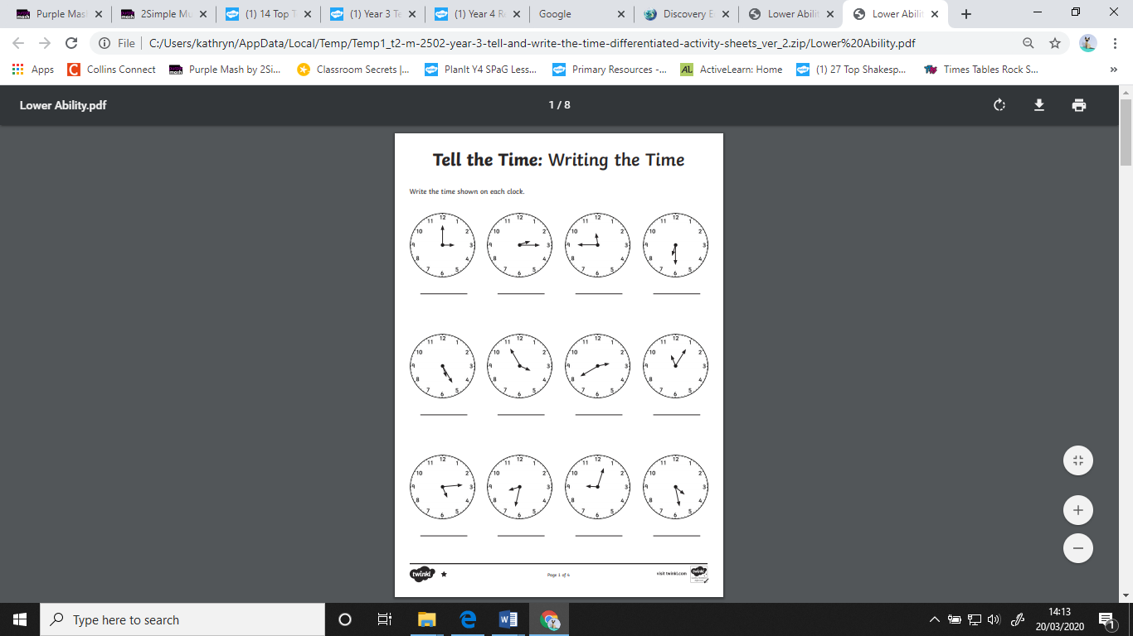

1. Time conversions

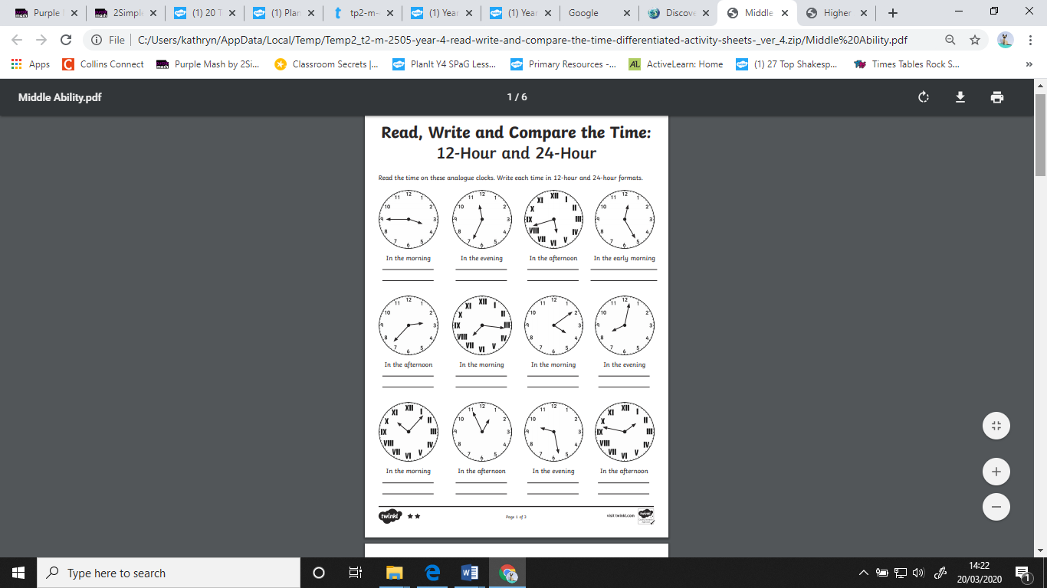

1. More challenging time conversions

Either print the sheet out and stick into your book, or just write in the timetable using the labelled columns as they are on the sheet.

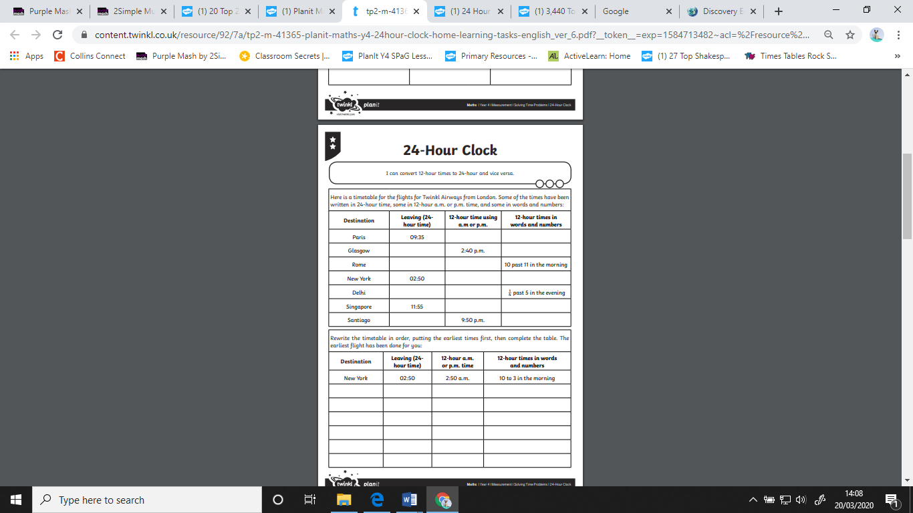

**Answers:**

